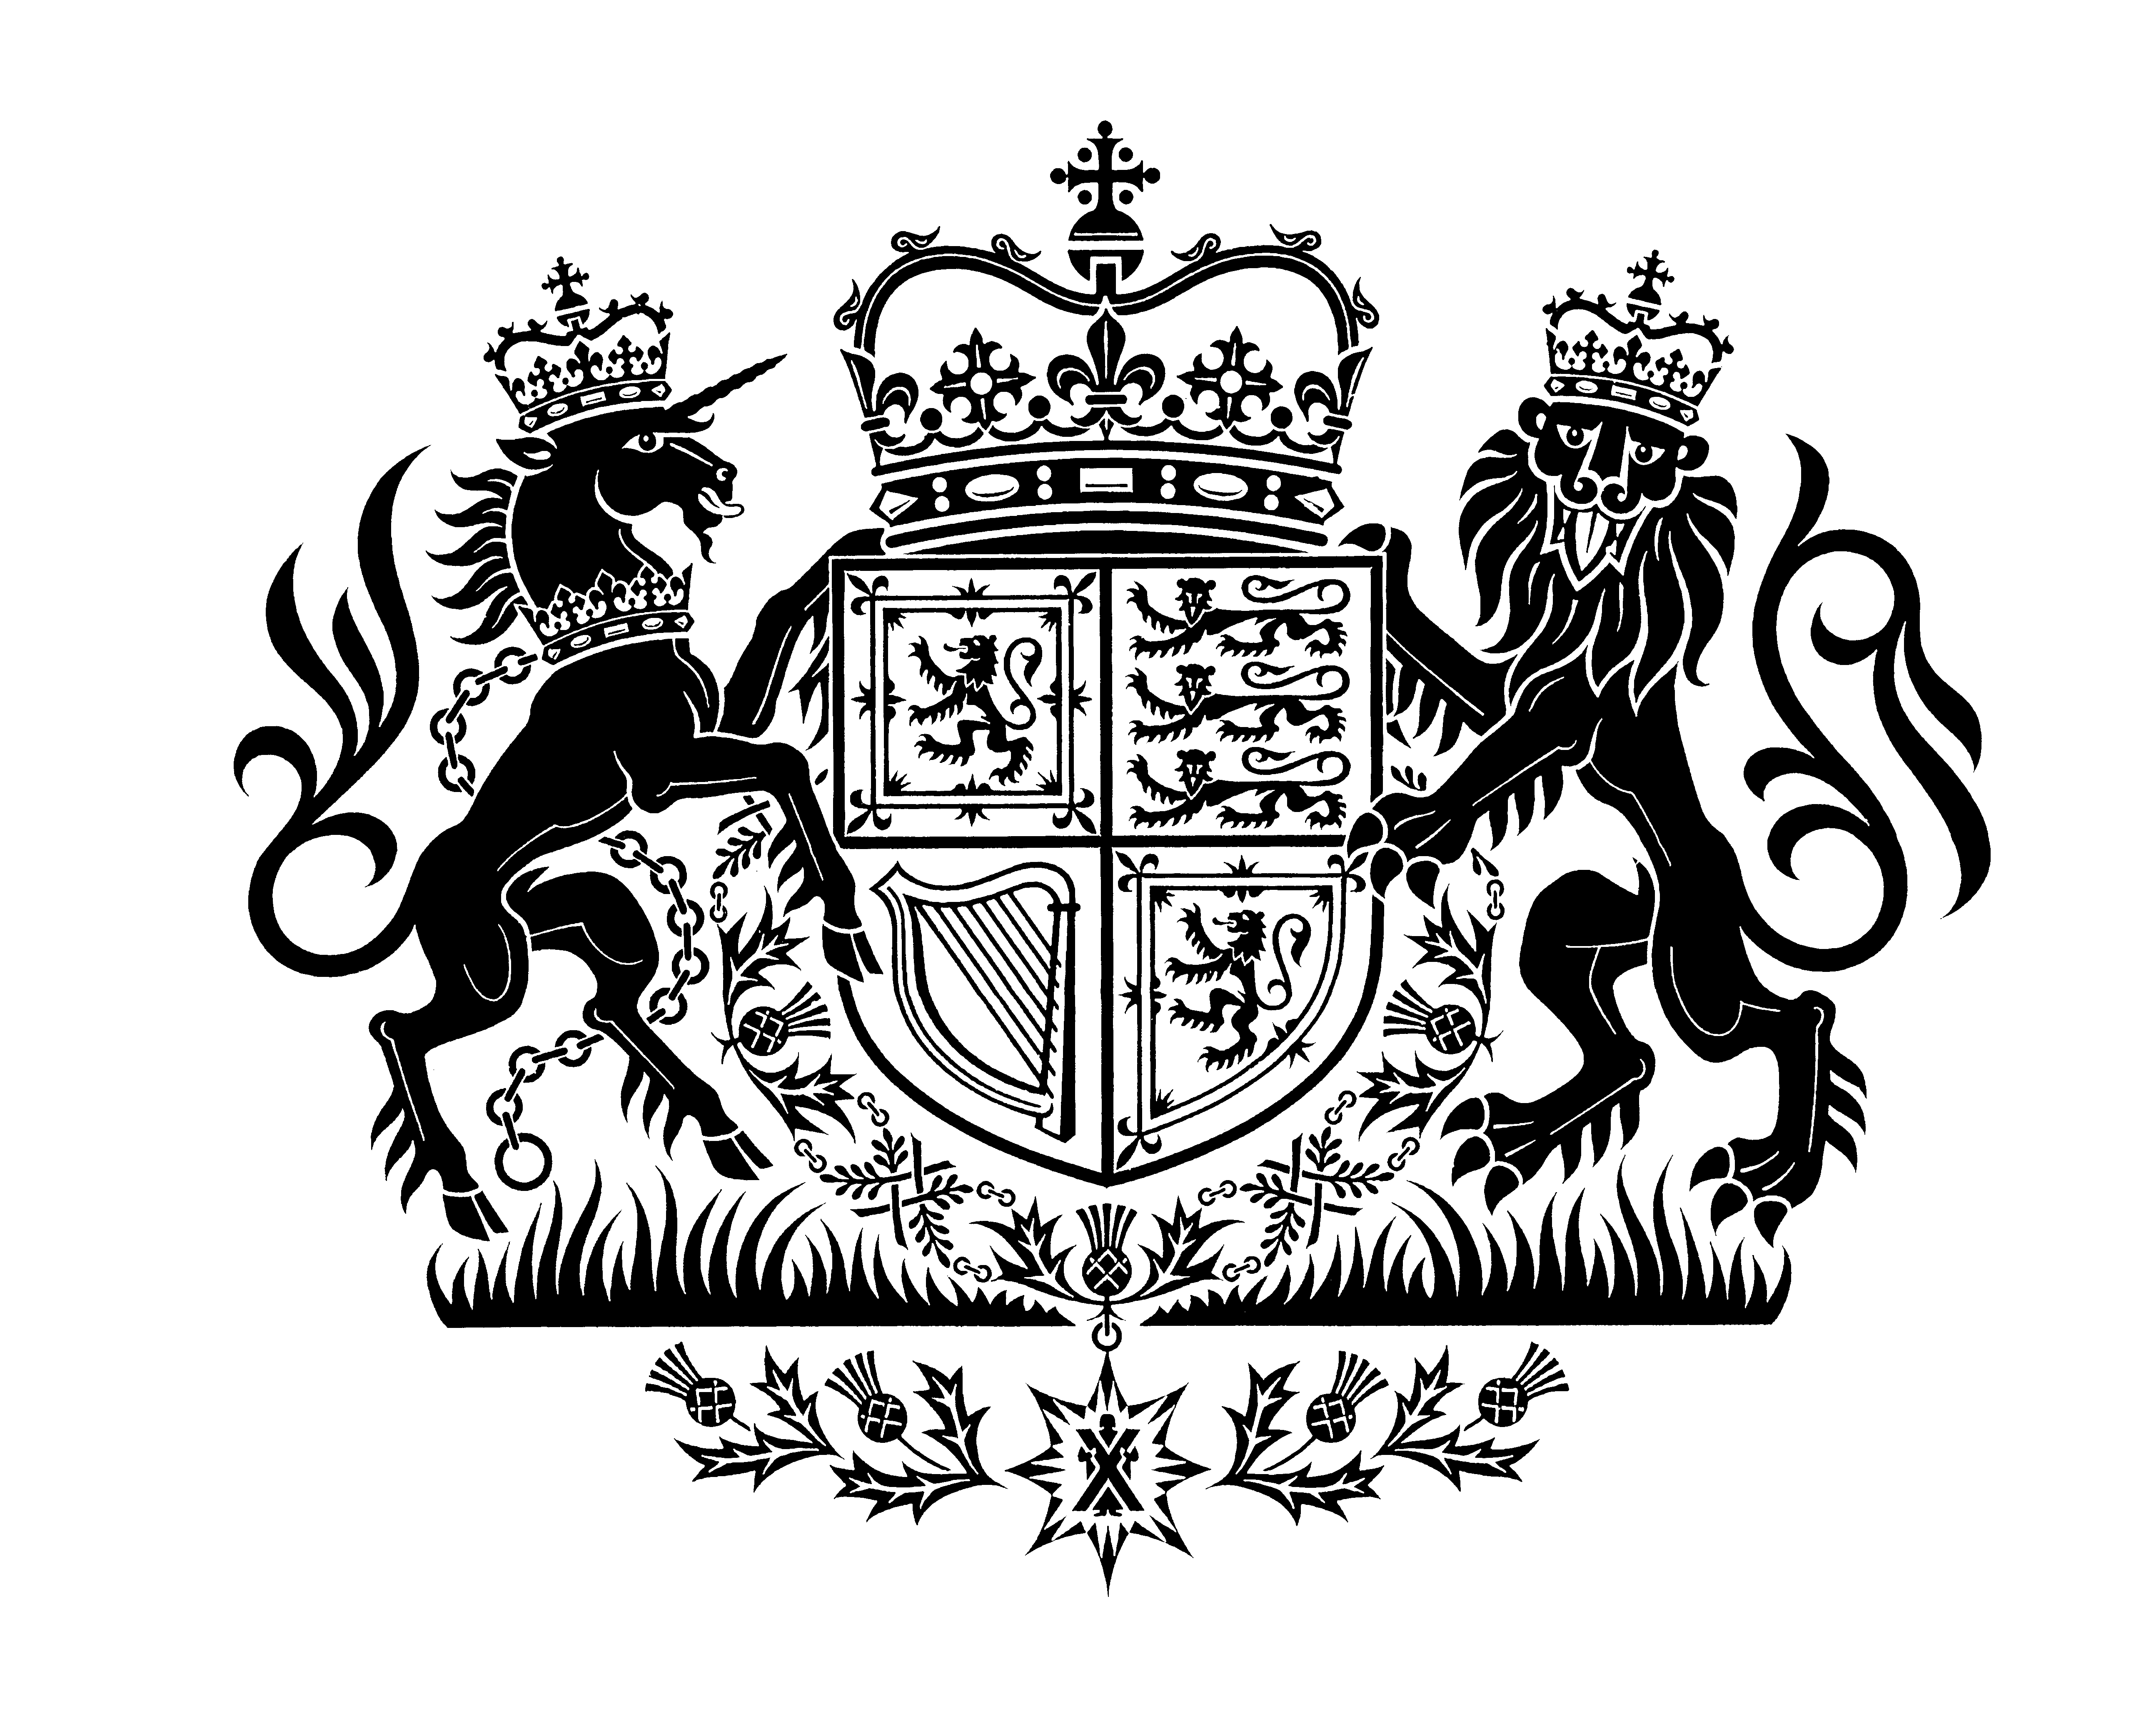

## 

Mental Health Tribunal for Scotland

We are pleased to intimate that the following candidates have been successful in obtaining appointment as legal members of the Mental Health Tribunal for Scotland.

|  |  |
| --- | --- |
| Eric Baijal | Katharine McKerrell |
| Bruce Beveridge | Colin Neilson |
| Joe Boyd | Ruth O’Hare |
| Stephanie Carr | Bobby Reid |
| Edward Christie | Ann Ritchie |
| Claire Currie | Amanda Sneddon |
| Susan Fallone | Laura Thomson |
| Sine Mackay | Agnete Wolff |

1 December 2024